Portable Bench Beam Scales
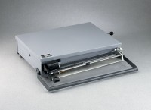 | Portable Bench Beam Scale - 131 lbs Capacity  Code: 88-1500  Attributes: Carrying Handle = Built-in, Description = Portable Bench Beam Scale - 131 lbs Capacity  Standards:

Portable Bench Beam Scale - 301 lbs Capacity
Code: 88-1520
Attributes: Carrying Handle = Built-in, Description = Portable Bench Beam Scale - 301 lbs Capacity
Standards:

