Cement Cube Mould (ASTM)
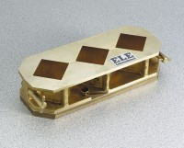 | Cement Cube Mould - ASTM  Code: 39-0412  Attributes: Base Plate = Machined forged bronze with knurled hold-down<br>screws., Description = Cement Cube Mould - ASTM  Standards: ASTM C87, ASTM C109, ASTM C141, ASTM C579, ASTM C593, AASHTO T106

 | Cover Plate  Code: 39-0412/10  Attributes: Description = Cover Plate  Standards:

Hard Rubber Tamper
Code: 39-0420
Attributes: Dimensions (l x w x h) mm = 1/2” x 1” x 6” (12 .7 x 25 .4 x 152 mm)., Description = Hard Rubber Tamper
Standards:

