Electronic Instrumentation
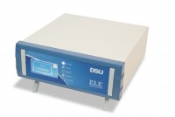 | DSU Electronic Readout and Control System 110 V AC 60 Hz  Code: 27-1300/02  Attributes: Description = DSU, Voltage Supply = 100-120 V 60 Hz  Standards:

DSU Electronic Readout and Control System 220 - 240 V AC 50/60 Hz
Code: 27-1300/01
Attributes: Voltage Supply = 220-240 V 50/60 Hz, Description = DSU
Standards:

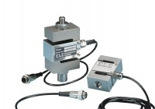 | 50kN S-type Load Cell  Code: 27-1559  Attributes: Description = S-type load cell - 50 kN, Value of CBR % = ALL, Environmental Protection = IP65, Force Capacity, kN = 50  Standards: EN 12697-34

 | Flow Transducer  Code: 45-6820  Attributes: Description = Flow Transducer  Standards: EN 12697-34

