Standard Compaction Mould
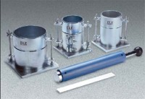 | Standard Compaction Mould  Code: 24-9097  Attributes: Mould Dimensions, i.d x h, ” = 4 x 4.584, Description = Standard Compaction Mould  Standards: ASTM D558, ASTM D559, ASTM D560, ASTM D698, ASTM D1557, AASHTO T99, AASHTO T134, AASHTO T135, AASHTO T136, AASHTO T180

