Curing Tank Heaters
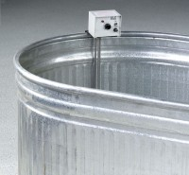 | Curing Tank Heater  Code: 34-6768/02  Attributes: Dimensions width x length, ” = 22.5, Description = Curing Tank Heater 110 V AC 50/60 Hz  Standards:

Curing Tank Heater
Code: 34-6765/01
Attributes: Dimensions width x length, ” = 22.5, Description = Curing Tank Heater 220 V AC 50/60 Hz
Standards:

