Elongation Index
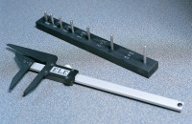 | Length Gauge  Code: 42-0820  Attributes: Description = Length Gauge, Weight, kg = 0.7  Standards: BS 812-105

