Sample Trays
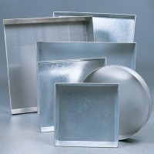 | Sample Tray - 306 x 306 x 38 mm  Code: 81-4020  Attributes: Dimensions length x width x height, mm = 306 x 306 x 38  Standards:

Sample Tray - 406 x 406 x 50 mm
Code: 81-4030
Attributes: Dimensions length x width x height, mm = 406 x 406 x 50
Standards:

Sample Tray - 610 x 610 x 63 mm
Code: 81-4080
Attributes: Dimensions length x width x height, mm = 610 x 610 x 63
Standards:

Sample Tray - 910 x 910 x 76 mm
Code: 81-4160
Attributes: Dimensions length x width x height, mm = 910 x 910 x 76
Standards:

Sample Tray - 1200 x 1160 x 50 mm
Code: 81-4230
Attributes: Dimensions length x width x height, mm = 1200 x 1160 x 50
Standards:

Sample Tray - 305 mm Diameter x 50 mm
Code: 81-4700
Attributes: Dimensions length x width x height, mm = 310 x 310 x 50
Standards:

