Accu-Tek 250 Series Cube Platen Sets
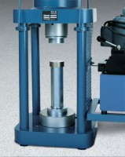 | Platen Set for 2" Cube  Code: 37-5514  Attributes: Dimensions, diameter x length, ” = 3 x 14.5, Description = Platen Set for 2″ Cube  Standards: ASTM C109, ASTM C39, AASHTO T22

 | Platen set for 6" Cube  Code: 37-5516  Attributes: Dimensions, l x w x h, ” = 6.5 x 6.5 x 6.25, Description = Platen set for 6″ Cube  Standards:

