Pressure Measurement
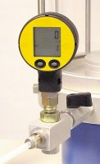 | Digital Pressure Gauge 1700Kpa. for Ele Triaxial Cells.  Code: 27-1620  Attributes: Description = Digital pressure gauge, Battery Life = 1400  Standards: ASTM D2850, ASTM D4767, ASTM D7181, ASTM D5084, AASHTO T296, AASHTO T297

 | Pressure Transducer Assembly 1700Kpa Fitted with 5 Pin Din Plug.  Code: 27-1633  Attributes: Description = Pressure transducer, Thread = 1 / 4  Standards:

