ASTM/AASHTO CBR mould and accessories
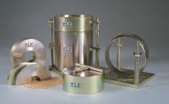 | ASTM Cbr Mould Complete with Collar & Perferated Base  Code: 24-9228  Attributes: Description = CBR mould with collar and baseplate, Base Plate = Perforated  Standards: ASTM D1883, AASHTO T193

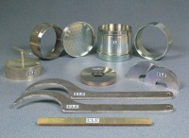 | ASTM Cutting Collar.  Code: 24-9236  Attributes: Description = CBR cutting collar, Mould Dimensions, i.d x h, ” = 6 x 1-1/2  Standards: ASTM D1883, AASHTO T193

 | ASTM Spacing Disc.  Code: 24-9238  Attributes: Description = CBR spacing disc, Finish = Plated  Standards:

Filter Screen 150mm Dia with 0.15mm Mesh.
Code: 24-9240
Attributes: Description = Filter screen, Mesh = Brass; no. 100
Standards:

4.5Kg Annular Surcharge Weight ASTM.
Code: 24-9243
Attributes: Description = 10 lb annular surcharge weight, Weight, kg = 4.5
Standards:

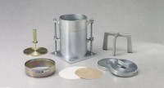 | 5Lb (2.27Kg) Split Surcharge Weight.  Code: 24-9244  Attributes: Description = 5 lb split surcharge weight, Finish = Plated  Standards:

5 Lb. Annular Surcharge Weight ASTM.
Code: 24-9245
Attributes: Description = 5 lb annular surcharge weight, Finish = Plated
Standards:

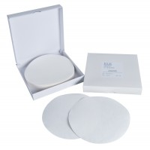 | Filter Paper Equivalent to Whatman No 5 150mm Dia Box of 100.  Code: 24-9250  Attributes: Description = Filter papers - 150 mm diameter, Size (height x width x diameter) cm = 5.9  Standards: ASTM D1883, AASHTO T193

