General Purpose Compression Machines
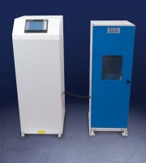 | ADR-Auto V2.0 2000 Standard Compression Machine  Code: 36-4125/01  Attributes: Voltage Supply = 220-240 V 50 Hz, Force Capacity, kN = 2000, Maximum Ram Travel mm = 50  Standards:

ADR-Auto V2.0 2000 Standard Compression Machine
Code: 36-4125/02
Attributes: Voltage Supply = 100-120 V 60 Hz, Force Capacity, kN = 2000, Maximum Ram Travel mm = 50
Standards:

ADR-Auto V2.0 2000 Standard Compression Machine
Code: 36-4125/06
Attributes: Voltage Supply = 220-240 V 60 Hz, Force Capacity, kN = 2000, Maximum Ram Travel mm = 50
Standards:

