Surface Hardness
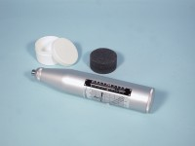 | Standard Concrete Test Hammer  Code: 35-1480  Attributes: Description = Standard Concrete Test Hammer, Accuracy, % = 15  Standards: ASTM C805

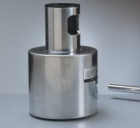 | Testing Anvil  Code: 35-1530  Attributes: Description = Testing Anvil, Weight, lbs = 37.06  Standards: ASTM C805

