Standard Bench Mixers
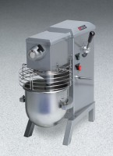 | Standard Bench Mixer  Code: 88-3000/02  Attributes: Motor hp, amp = 1 / 3, Description = Standard Bench Mixer  Standards:

