Proportional Caliper Device
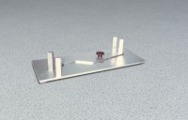 | Proportional Caliper Device  Code: 42-0405  Attributes: Weight, lbs = 7, Description = Proportional Caliper Device  Standards: ASTM D4791

