Hardened Concrete - Buoyancy Balance
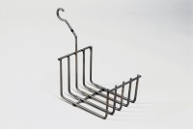 | Cradle  Code: 34-8105  Attributes: Description = Cradle, Weight, lbs = 1.24  Standards: EN 12697-32, EN 13280-4, BS 598-104

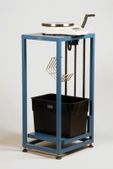 | Buoyancy Balance  Code: 34-8100/09  Attributes: Description = Buoyancy Balance, Power Supply = 110 - 240 V AC, 50 - 60 Hz, 1 ph  Standards: EN 12697-32, EN 13280-4, BS 598-104

