Soil and Gravel Auger Heads
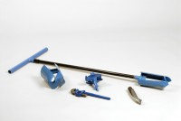 | 100mm Dia Soil Auger Head  Code: 23-1501  Attributes: Cohesive Soils = Yes, Nominal Diameter, mm = 100 mm, Weight, kg = 1.5  Standards:

150mm Dia Soil Auger Head
Code: 23-1504
Attributes: Nominal Diameter, mm = 150 mm, Cohesive Soils = Yes, Weight, kg = 2.5
Standards:

150mm Dia Gravel Auger Head.
Code: 23-1517
Attributes: Nominal Diameter, mm = 150 mm, Gravel and Sand = Yes, Weight, kg = 1.2
Standards:

50mm Dia Dutch Soil Auger Head.
Code: 23-1525
Attributes: Nominal Diameter, mm = 50 mm, Fine Silty Sand = Yes, Weight, kg = 1.5
Standards:

