Field Density Plates
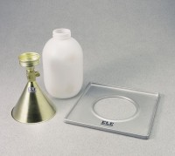 | 4" Field Density Plate  Code: 29-4294  Attributes: Diameter, ” = 4, Description = 4″ Field Density Plate  Standards: ASTM D1556, AASHTO T191

6" Field Density Plate
Code: 29-4342
Attributes: Description = 6″ Field Density Plate
Standards: ASTM D1556, AASHTO T191

