BS EN Compression Machines
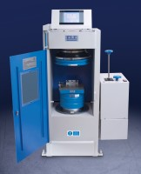 | ADR Touch 2000 BS EN Compression Machine with Digital Readout and Self Centring Platens.  Code: 36-3280/01  Attributes: Voltage Supply = 220-240 V 50/60 Hz, Force Capacity, kN = 2000, Maximum Ram Travel mm = 50 mm  Standards: EN 12350-6, NF P18-411

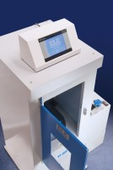 | ADR Touch 3000 BS EN Compression Machine with Digital Readout and Self Centring Platens.  Code: 36-3320/01  Attributes: Voltage Supply = 220-240 V 50/60 Hz, Force Capacity, kN = 3000, Maximum Ram Travel mm = 50 mm  Standards: EN 12350-6, NF P18-411

