Straightedge
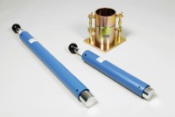 | Straight Edge 300mm.  Code: 24-9010  Attributes: Description = 300 mm straight edge  Standards: BS 1377-4, BS 1924-2, EN 1997-2, ASTM D698, ASTM D1557, AASHTO T99

