Air Content of Mortar, Masonry Cement and Lime by the Pressure Method
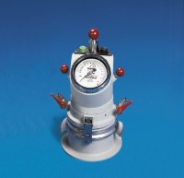 | Air Entrainment Meter  Code: 38-7087  Attributes: Capacity litres = 0.75, Description = Air Entrainment Meter  Standards: EN 413-2, BS 459-2

