Trowel
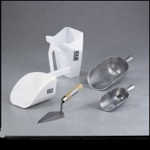 | Trowel  Code: 88-7400  Attributes: Construction = steel plated blade, Description = Trowel  Standards:

