Unconfined Compression Tester, Hand-Operated
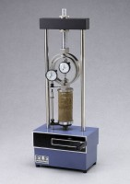 | Unconfined Compression Tester, Hand-Operated  Code: 25-3602  Attributes: Description = Unconfined Compression Tester, Hand-Operated 500 lb, Cross Head = High-strength aluminum.  Standards: ASTM D2166, AASHTO T208

Unconfined Compression Tester, Hand-Operated
Code: 25-3604
Attributes: Description = Unconfined Compression Tester, Hand-Operated 1,500 lb, Cross Head = High-strength aluminum.
Standards: ASTM D2166, AASHTO T208

Unconfined Compression Tester, Hand-Operated
Code: 25-3605
Attributes: Description = Unconfined Compression Tester, Hand-Operated 6.6 kN, Cross Head = High-strength aluminum.
Standards: ASTM D2166, AASHTO T208

