Spatulas
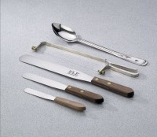 | Spatula - 4" Length  Code: 88-7500  Attributes: Construction = Stainless Steel, Description = Spatula - 4″ Length  Standards:

Spatula - 6" Length
Code: 88-7510
Attributes: Construction = Stainless Steel, Description = Spatula - 6″ Length
Standards:

Spatula - 10" Length
Code: 88-7520
Attributes: Construction = Stainless Steel, Description = Spatula - 10″ Length
Standards:

