Organic Impurities in Fine Aggregate
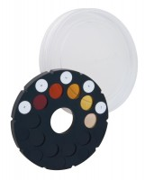 | Colour Standard to ASTM C40  Code: 42-3040  Attributes: Description = Colour Standard, Colour Standards = Five, on non-fading glass.  Standards: ASTM C40, AASHTO T21

 | Glass Bottle Approx.300Ml  Code: 42-3000  Attributes: Description = Glass Bottle, Weight, kg = 0.34  Standards: ASTM C40

