Displacement Measurement
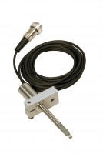 | Consolidation Transducer Assembly 15mm Travel Fitted with 5 Pin Din Plug.  Code: 27-1649  Attributes: Description = Displacement tranducer, Mounting Bracket = Included as standard.  Standards:

