Geotechnical Data Acquisition Unit (GDU)
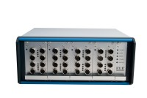 | GDU 8 Channel Data Acquisition Unit 220-240 V 50/60 Hz, 1 Ph.  Code: 27-1500/01  Attributes: Description = GDU 8 channel data acquisition unit, Transducer Supply = 10vDC., Voltage Supply = 220-240 V 50/60 Hz  Standards:

GDU 8 Channel Data Acquisition Unit 100-120 V 60 Hz
Code: 27-1500/02
Attributes: Voltage Supply = 100-120 V 60 Hz, Description = GDU 8 channel data acquisition unit, Transducer Supply = 10vDC.
Standards:

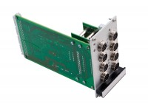 | 8-Channel Expansion Analog Input Module  Code: 27-1505  Attributes: Weight, lbs = 0.8, Description = 8-Channel Expansion Analog Input Module  Standards:

 | USB to Serial Adapter  Code: 27-1701  Attributes: Weight, lbs = 0.01, Description = USB to Serial Adapter  Standards:

