Linear Shrinkage
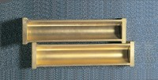 | Shrinkage Mould to BS 1377  Code: 24-1800  Attributes: Description = Shrinkage mould, Weight, kg = 0.3  Standards: BS 1377

 | Vernier Caliper Range 0 to 200mm X 0.02mm.  Code: 81-0588  Attributes: Description = Vernier caliper, Measuring Range mm = 0 - 200 mm x 0.02 mm  Standards: EN 933-4, BS 1377

