10" Flow Table
 | 10" Flow Table  Code: 38-6002  Attributes: Flow Mold = Machined bronze; 2-3/4” (69.8 mm) top i.d. x 4” (101.6 mm) base i.d. x 2” (50.8 mm) h., Description = 10″ Flow Table  Standards: ASTM C87, ASTM C109, ASTM C185, ASTM C230, ASTM C243, ASTM C348, AASHTO T71, AASHTO T106, AASHTO T137

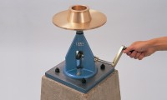 | Flow Mould  Code: 38-6040  Attributes: Description = Flow Mould  Standards: ASTM C230

ASTM Calipers
Code: 38-6080
Attributes: Description = ASTM Calipers
Standards: ASTM C230

