Color Standard Chart
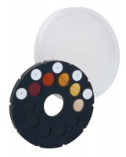 | Colour Standard to ASTM C40  Code: 42-3040  Attributes: Description = Colour Standard, Colour Standards = Five, on non-fading glass.  Standards: ASTM C40, AASHTO T21

