Oven Drying Method
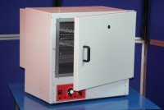 | 100 Litre Drying Oven  Code: 78-1225/01  Attributes: Description = Drying Oven, Capacity, litres = 100, No. of shelves supplied = 3, No. of shelf positions = 4, Temperature Fluctuation = +/- 0.75 °C, Internal Dimensions (length x width x height) mm = 460 x 490 x 450 mm, Temperature Range °C = 40 - 250 °C, Voltage Supply = 220-240 V 50/60Hz  Standards: BS 2648, BS 598, BS 1377, BS 1924

 | 150 Litre Drying Oven  Code: 78-1235/01  Attributes: Description = Drying Oven, Capacity, litres = 150, No. of shelves supplied = 3, No. of shelf positions = 5, Temperature Fluctuation = +/- 0.75 °C, Internal Dimensions (length x width x height) mm = 540 x 490 x 550 mm, Temperature Range °C = 40 - 250 °C, Voltage Supply = 220-240 V 50/60 Hz  Standards: BS 2648, BS 598, BS 1377, BS 1924

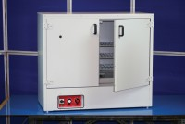 | 225 Litre Drying Oven  Code: 78-1250/01  Attributes: Description = Drying Oven, Capacity, litres = 225, No. of shelves supplied = 3, No. of shelf positions = 4, Temperature Fluctuation = +/- 0.75 °C, Internal Dimensions (length x width x height) mm = 440 x 920 x 600 mm, Temperature Range °C = 0 - 200 °C, Voltage Supply = 220-240 V 50/60 Hz  Standards: EN 12697-32, EN 13280-4, BS 598-104, BS 1377

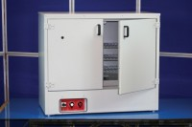 | 425 Litre Drying Oven  Code: 78-0135/01  Attributes: Description = Drying Oven, Capacity, litres = 425, No. of shelves supplied = 4, No. of shelf positions = 5, Temperature Fluctuation = +/- 0.75 °C, Internal Dimensions (length x width x height) mm = 640 x 920 x 760 mm, Temperature Range °C = 0 - 200 °C, Voltage Supply = 220-240 V 50/60 Hz  Standards: EN 12697-32, EN 13280-4, BS 598-104, BS 1377

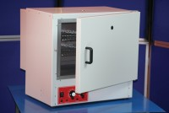 | 50 Litre Drying Oven  Code: 78-1215/01  Attributes: Description = Drying Oven, Capacity, litres = 50, No. of shelves supplied = 2, No. of shelf positions = 3, Temperature Fluctuation = +/- 0.75 °C, Internal Dimensions (length x width x height) mm = 330 x 490 x 330 mm, Temperature Range °C = 40 - 250 °C, Voltage Supply = 220-240 V 50/60 Hz  Standards: BS 2648, BS 598, BS 1377, BS 1924

