Fineness of Fly Ash (Wet Sieving)
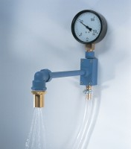 | Spray Nozzle Apparatus  Code: 38-7600  Attributes: Description = Spray Nozzle Apparatus, Weight, kg = 2.1  Standards: BS 3892-1, EN 451-2, ASTM C430

 | 45 μm Sieve  Code: 38-7600/12  Attributes: Description = 45 μm Sieve  Standards: BS 3892-1, EN 451-2, ASTM C430

