Light measurement
 | Campbell Stokes Sunshine Recorder for latitudes 0-45 N or S. Includes 1 year supply of charts.  Code: 505-062  Attributes: Description = Campbell Stokes Sunshine Recorder  Standards:

Accupar Ceptometer with 800mm Probe Datalogger and Rs232 Interface. Battery Powered.
Code: 505-067
Attributes: Description = Accupar Ceptometer with 800mm Probe Datalogger
Standards:

Large Tube Solarimeter Plain 5M.
Code: 505-070
Attributes: Description = Large Tube Solarimeter
Standards:

Solar Radiation Display and Integrator. for Use with Solar Sensors.
Code: 505-086
Attributes: Description = Solar Radiation Display and Integrator
Standards:

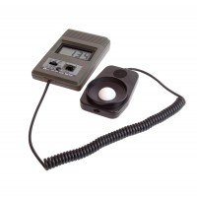 | Digital Lux Meter  Code: 505-092  Attributes: Description = Digital Lux Meter  Standards:

Light Measuring Unit (Luxmeter) with Sensor.
Code: 505-106
Attributes: Description = Light Measuring Unit (Luxmeter)
Standards:

