Proctor Penetrometer
 | Case for Proctor Penetrometer.  Code: 29-3933  Attributes: Description = Case for Proctor Penetrometer  Standards: ASTM D1558

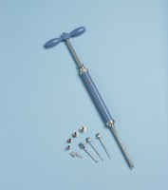 | Proctor Penetrometer Spring Type with Adaptor Stem.Supplied Complete with Set of Needle Points  Code: 29-3925  Attributes: Description = Proctor Penetrometer - complete with set of needle points, Weight, kg = 2  Standards: ASTM D1558

