Automatic Data Acquisition
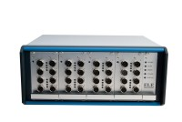 | GDU 8 Channel Data Acquisition Unit 220-240 V 50/60 Hz, 1 Ph.  Code: 27-1500/01  Attributes: Description = GDU 8 channel data acquisition unit, Transducer Supply = 10vDC., Voltage Supply = 220-240 V 50/60 Hz  Standards:

 | DS7.2 Undrained Triaxial Shear Strength Program for Windows 7, 32/64 bit  Code: 27-1753  Attributes: Description = DS7.2 Undrained Triaxial Shear Strength, GDU Compatability = Yes, DSU Compatability = Yes  Standards:

