4" Cylinder Capper
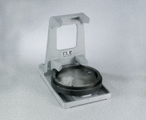 | 4" Cylinder Capper  Code: 34-6095  Attributes: Capping Plate = Two-piece construction; for 4” (102 mm) diam. specimens., Description = 4″ Cylinder Capper  Standards: ASTM C617, AASHTO T231

 | 2" Capping Plate  Code: 34-6095/10  Attributes: Dimensions, l x w x h, ” = 0.02 cu ft, Description = 2″ Capping Plate  Standards: ASTM C617, AASHTO T231

3" Capping Plate
Code: 34-6095/12
Attributes: Dimensions, l x w x h, ” = 0.03 cu ft, Description = 3″ Capping Plate
Standards: ASTM C617, AASHTO T231

