Heavy Duty Cylinder Carrier
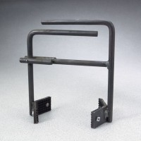 | Heavy-Duty Cylinder Carrier  Code: 34-5300  Attributes: Weight, lbs = 3, Description = Heavy-Duty Cylinder Carrier  Standards:

