Surveying Equipment
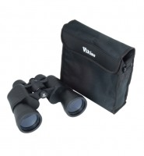 | Binoculars, 10x50  Code: 500-190  Attributes: Description = Binoculars  Standards:

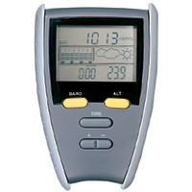 | Pocket altimeter  Code: 500-112  Attributes: Description = Pocket altimeter  Standards:

 | Electronic digital theodolite  Code: 500-175  Attributes: Description = Digital theodolite  Standards:

Automatic Level
Code: 500-170
Attributes: Description = Automatic Level
Standards:

Levelling staff, 4m
Code: 500-144
Attributes: Description = Levelling staff 4m
Standards:

Levelling staff, 5m
Code: 500-145
Attributes: Description = Levelling staff 5m
Standards:

Ranging rod
Code: 500-146
Attributes: Description = Ranging rod
Standards:

Land chain
Code: 500-154
Attributes: Description = Land chain
Standards:

Land chain arrows
Code: 500-156
Attributes: Description = Land chain arrows
Standards:

Clinometer
Code: 500-106
Attributes: Description = Clinometer
Standards:

Sighting Compass
Code: 500-108
Attributes: Description = Sighting Compass
Standards:

Land measurer
Code: 500-118
Attributes: Description = Land measurer
Standards:

Double prismatic square
Code: 500-126
Attributes: Description = Double prismatic square
Standards:

Abney level
Code: 500-132
Attributes: Description = Abney level
Standards:

Planimeter
Code: 500-140
Attributes: Description = Planimeter
Standards:

Nylon-coated steel tape
Code: 500-162
Attributes: Description = Steel tape
Standards:

