Vebe Time
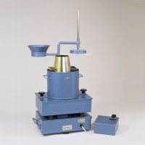 | Vibro Consistometer  Code: 34-0300/01  Attributes: Voltage Supply = 220 - 240 V AC, 50 Hz, 1 ph, Description = Vibro Consistometer  Standards:

