Bench Ovens
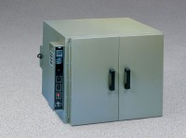 | Bench Oven - Hydraulic Thermostat - 7 cu. ft. capacity - 230vAC  Code: 88-0130/01  Attributes: Shelves = 2, Description = Bench Oven - Hydraulic Thermostat - 7 cu. ft. capacity - 230vAC  Standards:

Bench Oven - Hydraulic Thermostat - 7 cu. ft. capacity - 115vAC
Code: 88-0130/02
Attributes: Shelves = 2, Description = Bench Oven - Hydraulic Thermostat - 7 cu. ft. capacity - 115vAC
Standards:

Bench Oven - Digital PID Controller - 7 cu. ft. capacity - 230V
Code: 88-0140/01
Attributes: Shelves = 2, Description = Bench Oven - Digital PID Controller - 7 cu. ft. capacity - 230V
Standards:

Bench Oven - Digital PID Controller - 7 cu. ft. capacity - 115V
Code: 88-0140/02
Attributes: Shelves = 2, Description = Bench Oven - Digital PID Controller - 7 cu. ft. capacity - 115V
Standards:

