Stand, Bosshead and Clamp
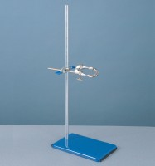 | Support Assembly  Code: 81-0094  Attributes: Description = Support Assembly  Standards:

