Digital Pressure Gauge
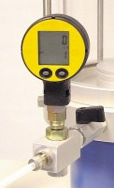 | Digital Pressure Gauge 1700Kpa. for Ele Triaxial Cells.  Code: 27-1620  Attributes: Description = Digital pressure gauge, Battery Life = 1400  Standards: ASTM D2850, ASTM D4767, ASTM D7181, ASTM D5084, AASHTO T296, AASHTO T297

 | Digital Pressure Gauge for Tri-Flex 2 and Permeability Cells  Code: 27-1622  Attributes: Battery Life = 1400, Description = Digital Pressure Gauge for Tri-Flex 2 and Permeability Cells  Standards: ASTM D2850, ASTM D4767, ASTM D7181, ASTM D5084, AASHTO T296, AASHTO T297

