Benkelman Beam
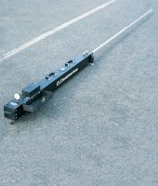 | Benkelman Beam  Code: 47-1460  Attributes: Description = Benkelman Beam, Open Length, ft. = 12  Standards: AASHTO T256

