Hand-held Digital Thermometers
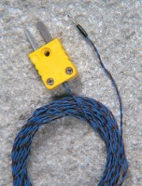 | Thermocouple Wire  Code: 82-5440/10  Attributes: Description = Thermocouple Wire, Nominal Diameter, mm = 0.5 mm  Standards:

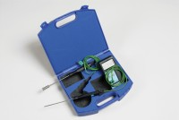 | Digital Thermometer  Code: 82-5442  Attributes: Description = Digital Thermometer, Temperature Range °C = -75 to +1200  Standards:

