Travelling Beam Device
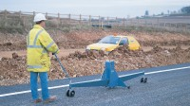 | Travelling Beam Device  Code: 47-3025  Attributes: Description = Travelling Beam Device, Weight, kg = 66  Standards: EN 12697-32, EN 13280-4, BS 598-104

 | Charts for Autographic Recorder  Code: 47-3130  Attributes: Description = Charts for Autographic Recorder, Weight, kg = 2.3  Standards: EN 12697-32, EN 13280-4, BS 598-104

Fibre-tipped Pen
Code: 47-3131
Attributes: Description = Fibre-tipped Pen
Standards: EN 12697-32, EN 13280-4, BS 598-104

