Economy Water Bath
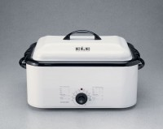 | Economy Water Bath  Code: 45-6475/02  Attributes: False Bottom = Grid-type, Description = Economy Water Bath  Standards:

