CBR Mould
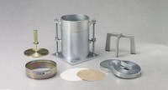 | CBR Mould  Code: 24-9229  Attributes: Collar height, ” = 2” h. (50.8 mm); fits both ends of mold., Description = CBR Mould  Standards: ASTM D1883, AASHTO T193

