Soil Mortar and Pestle
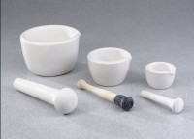 | Soil Mortar  Code: 88-6810  Attributes: Pestle length, ” = Rubber tip with wood handle;<br>8” (203 mm) long., Description = Soil Mortar  Standards:

Soil Pestle
Code: 88-6812
Attributes: Pestle length, ” = Rubber tip with wood handle;<br>8” (203 mm) long., Description = Soil Pestle
Standards:

