Accu-Tek Touch 250 Series
 | Frame Stand  Code: 37-5570  Attributes: Description = Frame Stand - 20-1/2 x 17-1/2 x 15 ”, Dimensions, l x w x h, ” = 20-1/2 x 17-1/2 x 15, For use with = Accu-Tek 250  Standards:

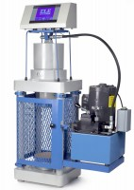 | Accu-Tek Touch 250 Series 110V/60Hz  Code: 36-0690/02  Attributes: Upper Platen = 6-1/4, Description = Accu-Tek Touch 250 Series 110V/60Hz  Standards: ASTM C39, AASHTO T22

Accu-Tek Touch 250 Series 220V/50Hz
Code: 36-0690/01
Attributes: Upper Platen = 6-1/4, Description = Accu-Tek Touch 250 Series 220V/50Hz
Standards: ASTM C39, AASHTO T22

Accu-Tek Touch 250 Series 220V/60Hz
Code: 36-0690/06
Attributes: Upper Platen = 6-1/4, Description = Accu-Tek Touch 250 Series 220V/60Hz
Standards: ASTM C39, AASHTO T22

Platen Set for 3" x 6" Cylinders
Code: 37-5508
Attributes: Dimensions, diameter x length, ” = 3 x 12.5, Description = Platen Set for 3″ x 6″ Cylinders
Standards: ASTM C39, AASHTO T22

Pedestal for Testing 4" x 8" Cylinders
Code: 37-5561
Attributes: Dimensions, diameter x length, ” = 6 x 4, Description = Pedestal for Testing 4″ x 8″ Cylinders
Standards: ASTM C39, AASHTO T22

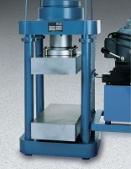 | Platen Set for 8" x 8" x 16" blocks  Code: 37-5522  Attributes: Description = Platen Set for 8″ x 8″ x 16″ blocks, Dimensions, l x w x h, ” = 8 x 16 x 6  Standards:

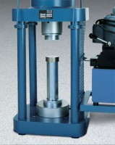 | Platen Set for 2" Cube  Code: 37-5514  Attributes: Dimensions, diameter x length, ” = 3 x 14.5, Description = Platen Set for 2″ Cube  Standards: ASTM C109, ASTM C39, AASHTO T22

Platen set for 6" Cube
Code: 37-5516
Attributes: Dimensions, l x w x h, ” = 6.5 x 6.5 x 6.25, Description = Platen set for 6″ Cube
Standards:

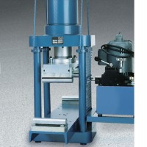 | Flexural Attachment  Code: 37-5528  Attributes: Description = Flexural Attachment - 79 kg, Upper Head = Fastens to upper platen by 4 spools.  Standards: ASTM C78, ASTM C293, AASHTO T97

Ram Seal Kit
Code: CT-992
Attributes: Dimensions, l x w x h, ” = 8 x 7 x 1, Description = Ram Seal Kit
Standards:

Accutek Oil
Code: 9806-0016
Attributes: Dimensions, l x w x h, ” = 6 x 6 x 12, Description = Accutek Oil
Standards: ASTM Grade 215, ISO Grade 46

