DataSystem Consolidation Test Set
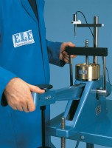 | DataSystem Consolidation Test Set 220 vAC  Code: 2230/01  Attributes: Rated Power = 220vAC, 50/60Hz, 1ø., Description = DataSystem Consolidation Test Set 220 vAC  Standards: ASTM D2435, ASTM D4546, AASHTO T216

DataSystem Consolidation Test Set 110 vAC
Code: 2230/02
Attributes: Rated Power = 110vAC, 50/60Hz, 1ø., Description = DataSystem Consolidation Test Set 110 vAC
Standards: ASTM D2435, ASTM D4546, AASHTO T216

