Soundness of Aggregates
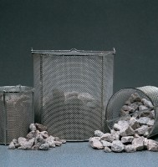 | Wire Basket - 150 μm wire mesh  Code: 81-4819  Attributes: Description = Wire Basket - 150 μm wire mesh, Aperture Size = 150 μm  Standards:

Wire Basket - 600 μm wire mesh
Code: 81-4821
Attributes: Description = Wire Basket - 600 μm wire mesh, Aperture Size = 600 μm
Standards:

Wire Basket - 1.18 mm wire mesh
Code: 81-4823
Attributes: Description = Wire Basket - 1.18 mm wire mesh, Aperture Size = 1.18 mm
Standards:

Wire Basket - 3.35 mm wire mesh
Code: 81-4825
Attributes: Description = Wire Basket - 3.35 mm wire mesh, Aperture Size = 3.35 mm
Standards:

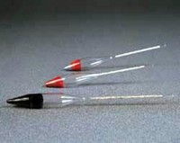 | Hydrometer  Code: 82-3505  Attributes: Description = Hydrometer used with sodium sulphate method  Standards: BS 812, EN 1367-2, ASTM C88, AASHTO T104

Hydrometer
Code: 82-3510
Attributes: Description = Hydrometer used with magnesium sulphate method
Standards: BS 812, EN 1367-2, ASTM C88, AASHTO T104

